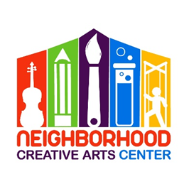

**Music Academy Individual Lessons**

**Financial Responsibility Contract**

**2025-2026**

By signing this agreement, you acknowledge your financial responsibilities to the NCAC. You acknowledge that you have read, understand, and agree to our Attendance Agreement.

Tuition may be paid for the entire year, for half year, or in monthly tuition installments. Tuition installments are due on the 20th of each month, August 2025 - May 2026. Please see a detailed summary of tuition below.

A materials fund for each student must be established at the beginning of your musical studies. This includes all administrative fees, assignment binder, backpack, copy fee, music books, MMF materials, and additional fees for the entire year. **The annual materials fee is $160/year and must be paid along with registration as a sign of commitment, allowing us to reserve your preferred lesson time for you. Without this payment, your lesson time may be claimed by another student.**

The commitment is for a 33-week term and unless we receive a 30-day notification of withdrawal, we assume you will be continuing your musical journey with us until the end of the school year.

**Tuition installments paid after the 20th will incur a $20 late fee.** If this late fee is not added to the tuition payment, it will be deducted from the materials deposit. Payment not made by the 30th of the month will result in lesson termination. All past-due accounts receive a courtesy email and text/phone call before lesson termination occurs. Should something come up where you cannot financially fulfill your commitment to your music lessons, we appreciate and encourage advanced notice and open, ongoing communication with us.

**Tuition Fees for 33 weeks of instruction\*\***

30 minute lessons: $1200 total annual payment*

OR

$600* semi-annual payment due August 20, 2025 and

January 20, 2026

OR

10 monthly payments of $120 due on the

20th of each month, August 2025 through May 2026

45 minute lessons: $1750 total annual payment*

OR

$875* semi-annual payment due August 20, 2025 and

January 20, 2026

OR

10 monthly payments of $175 due on the

20th of each month, August, 2025 through May, 2026

* **Payment may be made** by check payable to NCAC or online at www.neighborhoodcreativeartscenter.org/tuition-payments (password: 2024). Online payments allow you to set up automatic monthly tuition through May. PayPal, Venmo, and credit card options are available at checkout.

**Materials Fee ($160):**

Due upon registration. Payment of this fee is a sign of your commitment, allowing us to reserve your preferred lesson time for you. Without payment, your preferred lesson time may be claimed by another student. This payment may be made online at www.neighborhoodcreativeartscenter.org/tuition-payments (password: 2024).

Signature _________________________________________________________________

Today’s Date_______________________________________________________________

Email _____________________________________________________________________

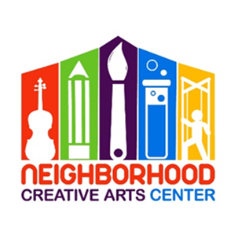**NCAC Individual Lesson**

**2025-2026 Tuition Schedule**

(Please keep this page for your records.)

At time of Registration: $160 materials fee, to reserve lesson time

20 August: Tuition Installment #1

20 September: Tuition Installment #2

20 October: Tuition Installment #3

20 November: Tuition Installment #4

20 December: Tuition Installment #5

20 January: Tuition Installment #6

20 February: Tuition Installment #7

20 March: Tuition Installment #8

20 April: Tuition Installment #9

20 May: Tuition Installment #10

Tuition Installment Amounts:

30-minute lessons: $120

45-minute lessons: $175