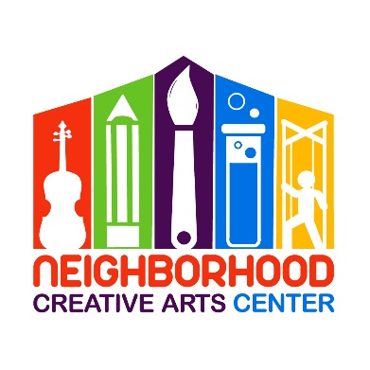
Neighborhood Creative Arts Center
Music Academy — Individual Lesson Registration Packet — 2026-2027
This single form covers registration, tuition, and our attendance policy — please complete, sign, and return with payment.
Student Information
Student's name ____________________________________________________________
Specialty/Specialties to be studied (piano, voice, instrument) _____________________________________________
Date of birth (under 18 only) ______________________ Age _______________
School attending ______________________________ Grade level _______________
Has your child studied music privately before? If so, how long, and what was the last book studied?
____________________________________________________________________________________________________
Parent/Guardian Information
Home address ______________________________________________________________________
City _________________________ State/Zip _________________________
Parent/Guardian 1 name (or self, if adult student): ______________________ | Relationship: ________________
Daytime phone: ______________________ | Cell phone: ______________________
Email: ___________________________________________________________________________
Parent/Guardian 2 name (optional): _______________________ | Relationship: ________________
Daytime phone: ______________________ | Cell phone: ______________________
Email: _______________________________________________________________________
Additional Information
Any special needs, allergies, or health considerations we should know about? No ___ Yes ___ (confidential explanation enclosed)
Any family religious beliefs that might impact repertoire choices or performance dates? No ___ Yes ___
If yes, please explain ____________________________________________________________
Who may we thank for referring you to us? __________________________________________________

Lesson Scheduling
Please list your top 3 preferred day/time options (lessons available Mon/Tue/Wed/Fri 1:30-7PM, Thurs 1:30-4PM, Sat 9AM-1PM):
1) ______________________________________________________________________
2) ______________________________________________________________________
3) ______________________________________________________________________
Preferred teacher (if any) ______________________________ In-person or virtual? _______________
Monthly Music Fest (MMF) Scheduling
MMFs happen on the fourth week of instruction each month. Please check the time that works best for your schedule — Ms. Georgia will contact you if a change is needed.
☐ Tuesday, 4:30-6:00 PM
☐ Tuesday, 6:15-7:45 PM
☐ Wednesday, 2-3:30 PM (Homeschool)
☐ Wednesday, 7:30-8:30 PM (Virtual)
☐ Thursday, 2-3:30 PM (Homeschool)
☐ Friday, 4:45-6:00 PM
☐ Friday, 6:15-7:45 PM (Teen students, all instruments)
Tuition & Fees (33 weeks of instruction, Sept 9, 2026 – June 7, 2027)
Please check lesson length and payment option:
☐ 30-minute lessons — $123/month × 10 months, OR $615 × 2 semi-annual payments (Aug 20 & Jan 20), OR $1,230 full payment (due Aug 20)
☐ 45-minute lessons — $178/month × 10 months, OR $900 × 2 semi-annual payments (Aug 20 & Jan 20), OR $1,800 full payment (due Aug 20)
Materials fee: $160/year, due at registration — reserves your child's lesson time. Covers music books, binder, backpack, teaching aids, MMF materials, and recital fees.
Payment: check payable to NCAC, or online at www.neighborhoodcreativeartscenter.org/tuition-payments (PayPal, Venmo, credit card; autopay available). Tuition paid after the 20th incurs a $20 late fee; accounts unpaid by the 30th may result in lesson termination (courtesy email/text/call sent first).
Commitment is for the full 33-week term; 30 days' written notice is required to withdraw.
Attendance & Program Policies
☐ Missed lessons are not made up — tuition covers your teacher's preparation, materials, and studio time, not just the lesson itself. If you know in advance, you may swap times with another student (confirm the swap by email to Ms. Georgia), request a virtual lesson, or use the time for a progress chat.
☐ For virtual lessons: be ready for the video call at lesson time. If there's no response within 10 minutes, the teacher will end the call attempt; text if joining late so the teacher can still begin. Missed virtual lessons are not rescheduled. Use a cellular connection if Wi-Fi is down.
☐ For unforeseen absences, please text Ms. Georgia at 301-542-9359 as a courtesy so she can inform the teacher.
☐ Refunds and credits are not issued for lessons missed or canceled by the student.
☐ My child's picture may be used in NCAC print/electronic media, unless I notify Ms. Georgia in writing within 2 weeks of registration.
☐ I accept full responsibility for my child while at NCAC activities.
Agreement
By signing below, I confirm I have read, understand, and agree to the registration, tuition, and attendance terms above.
__________________________________________________
(Signature of Parent, Guardian, or Adult Student)
Date ______________________________ Email ________________________________________

