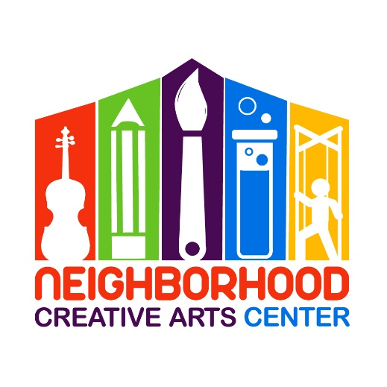
Office use only: Newsletter MMF

Music Academy Pre-K Music Lessons
Registration Form for 2023-2024
(This program is customized for students not yet entering Kindergarten in 2023.)

Student’s name ____________________________________________________________
Specialty to be studied (piano or violin) ____________________________________________________
Has your child studied music privately previously outside of NCAC? _________________________
If so, how long? __________________________Name of last music book studied __________________
Date of Birth (under 18 only) _____________________________ Age ____________________
School attending ______________________________________Grade Level____________
Home address _______________________________________________________________
City__________________________ State________ Zip Code__________________________
Parent or guardian name _______________________________________________________
Daytime phone____________________ Cell phone_______________________
E-mail address ___________________________________________________
Parent or guardian name ________________________________________________
Daytime phone____________________ Cell phone_______________________
E-mail address ____________________________________________________
Are there any personal circumstances of which I should be aware (special needs, allergies, health problems, etc?) No_______ Yes ________ (I am enclosing a confidential explanation.)
Are there any family religious beliefs that might impact repertoire choices or performance dates?
If so, please explain: __________________________________________________________________________
Who may we thank for referring you to us? ________________________________________________________

Music Academy Individual Lesson Tuition Schedule*
(33 weeks of instruction, September 11, 2023 - June 1, 2024)
Please circle type of payment:
30-minute lessons $100/month for 10 months,
2 semi-annual payments of $500, or
Full payment of $1000

*NCAC prefers payment by check, cash, or CashApp: $NCACmd
If paying through Paypal, please include an additional 3% to cover PayPal’s 3% transaction charge. Thank you!
Materials Fee
Students will need $120 for a year’s supplies. This fee covers music books, binder, backpack, teaching aids for the year, and administrative costs. This fee must be paid along with registration. Your payment of this fee is a sign of commitment from you, allowing us to reserve your preferred lesson time for your child.

Individual Lesson Scheduling Options
Please let us know your top three choices for a lesson time. We have listed the days and times that lessons are available.
Monday (3:30-8PM):__________________________________________________________________
Tuesday (3:30-8PM):__________________________________________________________________
Wednesday (3:30-8PM):_______________________________________________________________
Thursday (3:30-8PM):_________________________________________________________________
Friday (3:30-8PM):____________________________________________________________________
Preferred Teacher(s) ________________________________________________________
Would you prefer In-Person or Virtual Lessons? __________________________________________
If the Charles County public schools pivot to a virtual platform due to COVID-19, NCAC will also pivot to a virtual platform.
Your child will attend a Music Fest every fourth week, in place of their individual lesson. Please indicate which day/time your child will be attending: ___Thursday, 4:30-5:45: Primer group (4-6 years) or ___Friday, 4:45-6:00: Primer group (4-6 years). The Music Fest schedule will be placed in your child’s binder and can be found on the Events page of the NCAC website.

IMPORTANT
- I have read and agree to the terms of the current Neighborhood Creative Arts Center Registration Form, Financial Agreement and Attendance Agreement.
- I accept full responsibility for my child while at NCAC.
- By attending live lessons, I voluntarily assume all risks related to exposure to COVID-19. Also, by attending live lessons, I affirm that all who attend the lesson are healthy and have not exhibited any signs of illness (COVID-19) in the 14 days before my child’s lesson. If, on the day of the lesson, I or my child are experiencing severe symptoms, I will schedule virtual lessons until all coming into NCAC have not exhibited serious signs of illness for 14 days.
- The following items must be turned in at time of registration: completed Registration form, Financial Agreement, and Attendance Policy and Materials deposit.
- I understand that my child’s picture may be used in print and electronic media. If I am not comfortable with this, I will notify Ms Georgia in writing within 2 weeks of registration.
- Payment may be made with cash, checks payable to NCAC, CashApp: $NCACmd, or PayPal (through msgeorgia@neighborhoodcreativeartscenter.org, please include 3% service charge).
- Refunds and credits will not be made for lessons missed or canceled by the student.

___________________________________________________________________________________________
(Signature of Parent, Guardian, or Adult Student) Date

