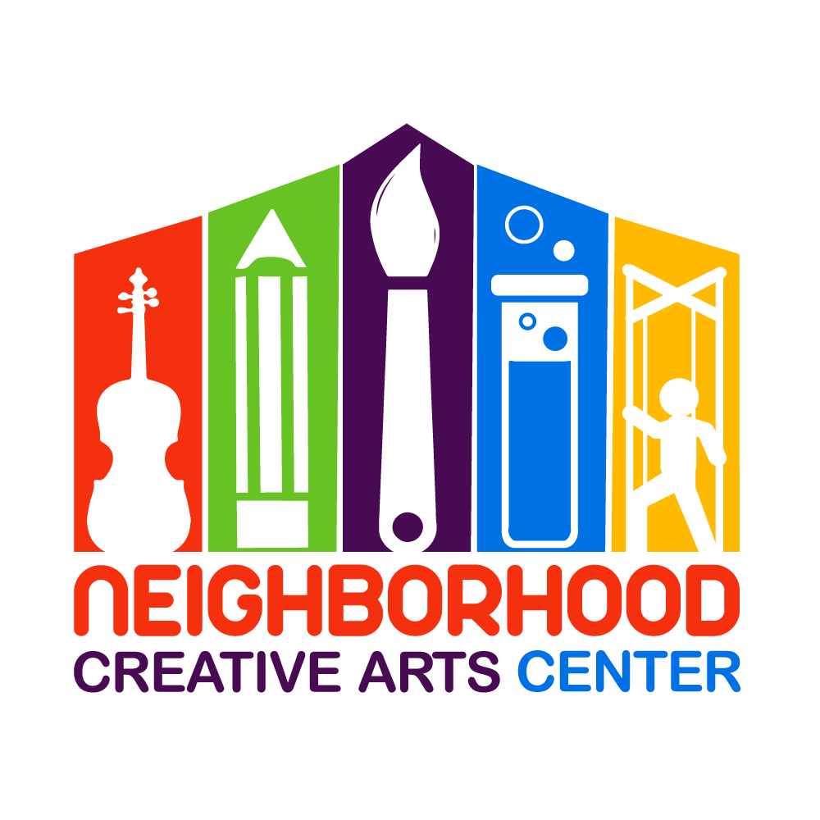
Neighborhood Creative Arts Center
Home School Academy
2020 - 2021 Calendar

Fun Fridays
Session 1: Feb. 7, 14, 21, 28
Session 2: Mar. 13, 20, 27, Apr. 3
Session 3: May 1, 8, 15, 22

Homeschool Academy (Tuesdays and Thursdays)
Week 1: August 25 and 27, 2020 - Open House Week
Week 2: September 1 and 3, 2020
Week 3: September 8 and 10, 2020
Week 4: September 15 and 17, 2020
Week 5: September 22 and 24, 2020
Week 6: September 29 and October 1, 2020
Week 7: October 6 and 8, 2020
Week 8: October 13 and 15, 2020
Week 9: October 20 and 22, 2020
Week 10: October 27 and 29, 2020
Week 11: November 3 and 5, 2020
Week 12: November 10 and 12, 2020
Week 13: November 17 and 19, 2020

November 20 - 30, 2020 THANKSGIVING BREAK, CENTER CLOSED
Week 14: December 1 and 3, 2020
Week 15: December 8 and 10, 2020
Week 16: December 15 and 17, 2020
December 18 - January 18, 2020 WINTER BREAK, CENTER CLOSED

Week 1: January 19 and 21, 2021
Week 2: January 26 and 28, 2021
Week 3: February 2 and 4, 2021
Week 4: February 9 and 11, 2021
Week 5: February 16 and 18, 2021
Week 6: February 23 and 25, 2021
Week 7: March 2 and 4, 2021
Week 8: March 9 and 11, 2021
Week 9: March 16 and 18, 2021
Week 10: March 23 and 25, 2021

March 26 - April 12, 2021 SPRING BREAK, CENTER CLOSED

Week 11: April 13 and 15, 2021
Week 12: April 20 and 22, 2021
Week 13: April 27 and 29, 2021
Week 14: May 4 and 6, 2021
Week 15: May 11 and 13, 2021
Week 16: May 18 and 20, 2021

SUMMER BREAK
We follow Charles County School Weather Cancellations based on our location. An email will be sent to announce weather-related closures.

