*Office use only: Newsletter MMF* 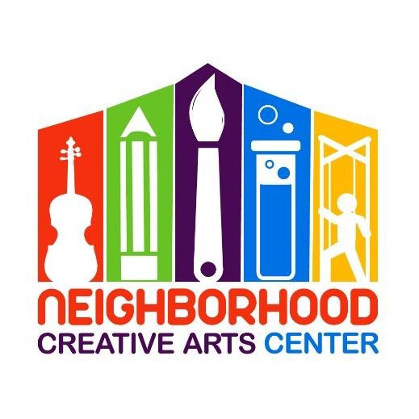

**Music Academy Pre-K Music Lessons**

**Registration Form for 2025-2026**

**(This program is customized for students not yet entering Kindergarten in 2025.)**

Student’s name ____________________________________________________________

Specialty to be studied (piano or violin) ____________________________________________________

Has your child studied music privately outside of NCAC? _________________________

If so, how long? __________________________Name of last music book studied __________________

Date of Birth (under 18 only) _____________________________ Age ____________________

School attending ______________________________________Grade Level____________

Home address _______________________________________________________________

City__________________________ State________ Zip Code__________________________

Parent or guardian name _______________________________________________________

Daytime phone____________________ Cell phone_______________________

E-mail address ___________________________________________________

Parent or guardian name ________________________________________________

Daytime phone____________________ Cell phone_______________________

E-mail address ____________________________________________________

Are there any personal circumstances of which I should be aware (special needs, allergies, health problems, etc?) No_______ Yes ________ (I am enclosing a confidential explanation.)

Are there any family religious beliefs that might impact repertoire choices or performance dates?

If so, please explain: __________________________________________________________________________

Who may we thank for referring you to us? ________________________________________________________

**Music Academy Individual Lesson Tuition Schedule\***

**(33 weeks of instruction, September 9, 2025 - June 7, 2026)**

Please circle type of payment:

30-minute lessons $105/month for 10 months ,

2 semi-annual payments of $525, or

Full payment of $1050

**Payment may be made** by check payable to NCAC or online at www.neighborhoodcreativeartscenter.org/tuition-payments (password: 2024). Online payments allow you to set up automatic monthly tuition through May. PayPal, Venmo, and credit card options are available at checkout.

** If you are joining mid-term, a prorated Tuition Schedule will be emailed to you.

Thank you!

**Materials Fee**

Students will need $120 for a year’s supplies. This fee covers music books, binder, backpack, teaching aids for the year, and administrative costs. This fee must be paid along with registration. Your payment of this fee is a sign of commitment from you, allowing us to reserve your preferred lesson time for your child. This payment may be made online at www.neighborhoodcreativeartscenter.org/tuition-payments (password: 2024).

**Individual Lesson Scheduling Options**

Please let us know your top three choices for a lesson time. We have listed the days and times that lessons are available.

Monday (3:30-8PM):__________________________________________________________________

Tuesday (1:30-8PM):__________________________________________________________________

Wednesday (1:30-8PM):_______________________________________________________________

Thursday (1:30-4PM):_________________________________________________________________

Friday (1:30-8PM):____________________________________________________________________

Preferred Teacher(s) ________________________________________________________

Would you prefer In-Person or Virtual Lessons? __________________________________________

**IMPORTANT**

* I have read and agree to the terms of the current **Neighborhood Creative Arts Center** Registration Form, Financial Agreement and Attendance Agreement.
* I accept full responsibility for my child while at NCAC.
* The following items must be turned in at time of registration: completed Registration form, Financial Agreement, and Attendance Policy and Materials deposit.
* I understand that my child’s picture may be used in print and electronic media. If I am not comfortable with this, I will notify Ms Georgia in writing within 2 weeks of registration.
* This payment may be made online at www.neighborhoodcreativeartscenter.org/tuition-payments (password: 2024).Refunds and credits will not be made for lessons missed or canceled by the student.

________________________________________________________________________________________

(Signature of Parent, Guardian, or Adult Student) Date