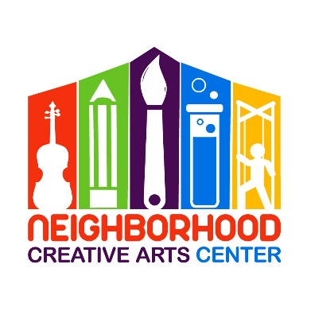
Office use only: Newsletter MMF
Music Academy Individual Lessons
Registration Form for 2025-2026

Student’s name _________________________________________________________________
Specialty/Specialties to be studied (piano, voice, instrument) ______________________________
Has your child studied music privately previously? _______________________________________
If so, how long? __________________Name of last music book studied __________________
Date of Birth (under 18 only) _____________________________ Age __________________
School attending ______________________________________Grade Level____________
Home address _______________________________________________________________
City__________________________ State________ Zip Code________________________
Parent or guardian name _______________________________________________________
Daytime phone____________________ Cell phone_______________________
E-mail address ___________________________________________________
Parent or guardian name ________________________________________________
Daytime phone____________________ Cell phone_______________________
E-mail address ____________________________________________________
Are there any personal circumstances of which I should be aware (special needs, allergies, health problems, etc?) No_______ Yes ________ (I am enclosing a confidential explanation.)
Are there any family religious beliefs that might impact repertoire choices or performance dates?
If so, please explain: __________________________________________________________________________
Who may we thank for referring you to us? ________________________________________________________

Music Academy Individual Lesson Tuition Schedule*
(33 weeks of instruction, September 9, 2025 - June 7, 2026)
Please check the desired length of lesson and circle type of payment:
______ 30 minute $!20/month for 10 months due on the 20th of each month, August through May, OR
2 semi-annual payment of $600* due August 20, 2025 and January 20, 2026, OR
Full payment of $1200 * due August 20
______45 minute $175/month for 10 months due on the 20th of each month, August through May, OR
2 semi-annual payments of $875* due August 20, 2025 and January 20, 2026, OR
Full payment of $1750* due August 20
Payment may be made by check payable to NCAC or online at www.neighborhoodcreativeartscenter.org/tuition-payments (password: 2024). Online payments allow you to set up automatic monthly tuition through May. PayPal, Venmo, and credit card options are available at checkout.
Materials/Registration Fee – to be paid at the time of registration
Students will need $160 for a year’s supplies. This fee covers music books, binder, backpack, and teaching aids for the year, MMF materials, and recital fees. This fee must be paid along with registration. Your payment of this fee is a sign of commitment from you, allowing us to reserve your preferred lesson time for your child.
Individual Lesson Scheduling Options
Please let us know your top three choices for a lesson time. We have listed the days and times that lessons are available.
Monday (1:30-8PM):__________________________________________________________________
Tuesday (1:30-8PM):__________________________________________________________________
Wednesday (1:30-8PM):_______________________________________________________________
Thursday (1:30-4 PM):_________________________________________________________________
Friday (1:30-8PM):____________________________________________________________________
Preferred NCAC Teacher(s) ________________________________________________________
Would you prefer In-Person or Virtual Lessons? __________________________________________

Monthly Music Fest Scheduling
Monthly Music Fests (MMF’s) happen on every fourth week of instruction. Ideally, students should attend the same day/time of MMF each month. You can reschedule during the year, but it is best if students are able to establish friendships throughout the year with the other students in their MMF group. The 2025-2026 schedule is below. Please check the MMF your child will be attending. If it becomes apparent that your child would thrive in another MMF and should be moved, Ms. Georgia will contact you.
___Tuesday, 4:30-6:00 PM
___Tuesday, 6:15-7:45 PM
___Wednesday, 4:30-6:00 PM
___Wednesday, 7:30 – 8:30 PM: Virtual Music Fest
___Friday, 4:45-6:00:
___Friday, 6:15-7:45: Teen students (all instruments, piano, voice)
IMPORTANT
- I have read and agree to the terms of the current Neighborhood Creative Arts Center Registration Form, Financial Agreement, and Attendance Agreement.
- I accept full responsibility for my child while at NCAC.
- The following items must be turned in at time of registration: completed Registration form, Financial Agreement, Attendance Policy, and Materials deposit.
- I understand that my child’s picture may be used in print and electronic media. If I am not comfortable with this, I will notify Ms Georgia in writing within 2 weeks of registration.
- Payment may be made by check payable to NCAC or online at www.neighborhoodcreativeartscenter.org/tuition-payments (password: 2024). Online payments allow you to set up automatic monthly tuition through May. PayPal, Venmo, and credit card options are available at checkout.
- Refunds and credits will not be made for lessons missed or canceled by the student.

___________________________________________________________________________________________
(Signature of Parent Guardian) Date

