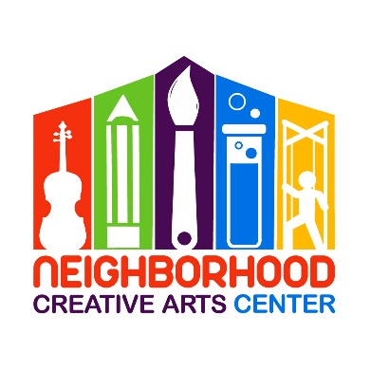
Music Academy Individual Lessons
Attendance Agreement 2023-2024

Thank you for choosing NCAC for your child’s music adventure! In order to ensure that you and your child get the most effective and creative teaching possible, we have established the following policy regarding attendance.
If a student misses a lesson, they will simply miss the benefit of that lesson. Remember that your tuition pays for far more than just lesson time with your child. Your tuition covers your teacher’s preparation time, the time to seek out new music, the time to explore new teaching ideas and methods, your teacher’s experience and training, studio expenses, and much more.
If pursuing virtual lessons, please be ready to receive a zoom invitation at the time of your child’s lesson. If you do not respond within 10 minutes, the teacher will leave the zoom room. You are welcome to text them if you are joining after the first 10 minutes so they can reopen the room. To protect teachers’ family and personal time, missed virtual lessons will not be made up. If your wi-fi is not functioning, please use your cellular connection.
However, if you foresee that your child will be missing a lesson, you may 1.) opt to use the swap roster to trade lesson times with another student, 2.) request a virtual lesson through Zoom for a long distance lesson from your home, or 3.) simply call to chat about your child’s progress during the time that is reserved for your child. If you choose to swap, you must forward Ms Georgia the email conversation with the other student confirming the swap to keep everyone informed. If the swap information for a virtual lesson is not communicated, we will not be able to send the zoom invitation to the correct student. Please make these arrangements with Ms Georgia as soon as possible so your teacher can be informed and plan ahead for your child’s virtual lesson.
Lastly, if your child is going to miss their lesson due to unforeseen circumstances, please send a courtesy text (301-542-9359) to Ms. Georgia so she can inform their teacher. Thank you!

Parent or Guardian Signature _____________________________________________
Today’s Date___________________________________________________________
Email _________________________________________________________________

